**UNIT – II**

# TRANSMISSION MEDIA



## TRANSMISSION MEDIA

**Media are roughly grouped into two:**

* + 1. **Guided media, the transmission takes place using wires such as copper wire and fiber optics**
    2. **Unguided media, the transmission takes place without using wires such as radio and lasers through the air.**

## GUIDED TRANSMISSION MEDIA

Various physical media can be used for the actual transmission. Each one has its own niche in terms of bandwidth, delay, cost, and ease of installation and maintenance.

* 1. **Magnetic Media**
  2. **Twisted Pair**
  3. **Coaxial Cable**
  4. **Fiber Optics**
  5. **Fiber Cables**



1. **MAGNETIC MEDIA**

One of the most common ways to transport data from one computer to another is to write them onto magnetic tape or removable media (e.g., recordable DVDs), physically transport the tape or disks to the destination machine, and read them back in again.

Transmission time is measured in minutes or hours, not milliseconds.

## TWISTED PAIR

A twisted pair consists of two insulated copper wires, typically about 1 mm thick. The wires are twisted together in a helical form, just like a DNA molecule. Twisted pairs can be used for transmitting either analog or digital signals. The bandwidth depends on the thickness of the wire and the distance traveled, but several megabits/sec can be achieved for a few kilometers.

* 1. **Category 3 twisted pairs **
  2. **Category 5 twisted pairs **

All of these wiring types are often referred to as UTP (Unshielded Twisted Pair)

## COAXIAL CABLE

It has better shielding than twisted pairs, so it can span longer distances at higher speeds. Two kinds of coaxial cable are widely used.

* **50-ohm cable, is commonly used when it is intended for digital transmission.**
* 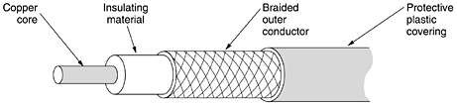**75-ohm cable, is commonly used for analog transmission and cable television.**

## FIBER OPTICS

An optical transmission system has three key components:

* + **Light source**
  + **Transmission medium**
  + **Detector**

## FIBER CABLES

The core is surrounded by a glass cladding with a lower index of refraction than the core, to keep all the light in the core. Next comes a thin plastic jacket to protect the cladding. Fibers are typically grouped in bundles, protected by an outer sheath.

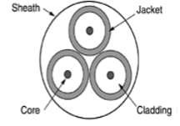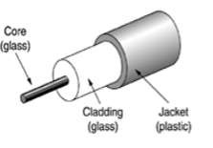

Side view of a single fiber End view of a sheath with three fibers

Two kinds of light sources are typically used to do the signaling, LEDs (Light Emitting Diodes) and semiconductor lasers.

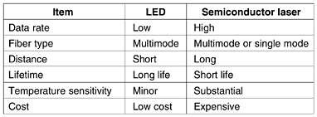

Two types of interfaces are used.

**FIBER OPTIC NETWORKS**

* 1. **Passive interface 2. Active interface / repeater**

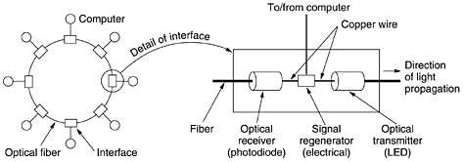

**A PASSIVE STAR CONNECTION - FIBER OPTICS NETWORK**

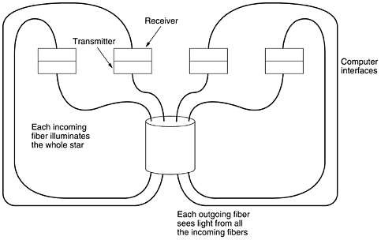

## UNGUIDED TRANSMISSION MEDIA

The transmission takes place without using wires such as radio and lasers through the air.

* 1. **Wireless Communication**

1. **The Electromagnetic Spectrum**
2. **Radio Transmission**
3. **Microwave Transmission**
4. **Infrared and Millimeter Waves**
5. **Lightwave Transmission**
   1. **Communication Satellites**
6. **Geostationary Satellites**
7. **Medium-Earth Orbit Satellites**
8. **Low-Earth Orbit (LEO) Satellites**

## THE ELECTROMAGNETIC SPECTRUM

When electrons move, they create electromagnetic waves that can propagate through space. The number of oscillations per second of a wave is called its frequency f, and is measured in Hz (in honor of Heinrich Hertz). The distance between two consecutive maxima (or minima) is called the wavelength, which is universally designated by the Greek letter l (lambda).

The fundamental relation between f, l, and c (in vacuum) is, λf = c

The amount of information that an electromagnetic wave can carry is related to its bandwidth.

The electromagnetic spectrum and its uses for communication:

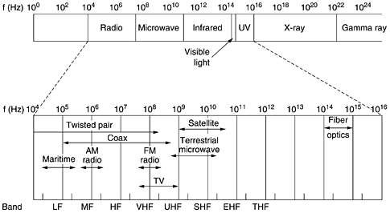**The terms LF, MF, and HF refer to low, medium, and high frequency, respectively and higher bands were Very, Ultra, Super, Extremely, and Tremendously High Frequency bands (VHF, UHF, EHF and THF).**

### RADIO TRANSMISSION

Radio waves are easy to generate, can travel long distances, and can penetrate buildings easily, so they are widely used for communication, both indoors and outdoors. Radio waves also are omnidirectional, meaning that they travel in all directions. The properties of radio waves are frequency dependent.

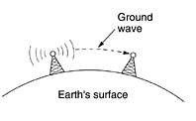 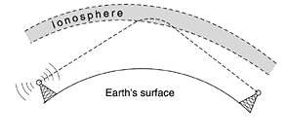

### MICROWAVE TRANSMISSION

Microwaves formed the heart of the long-distance telephone transmission system. Since the microwaves travel in a straight line. Microwaves do not pass through buildings well. The delayed waves may arrive out of phase with the direct wave and thus cancel the signal. This effect is called multipath fading.

Microwave communication is so widely used for long-distance telephone

communication, mobile phones, television distribution, and other uses that a

severe shortage of spectrum has developed.



## INFRARED AND MILLIMETER WAVES

Unguided infrared and millimeter waves are widely used for short-range communication. The remote controls used on televisions, VCRs, and stereos all use infrared communication. They are relatively directional, cheap, and easy to build but have a major drawback: they do not pass through solid objects.

Infrared communication has a limited use on the desktop, for example,

connecting notebook computers and printers.

## LIGHT WAVE TRANSMISSION

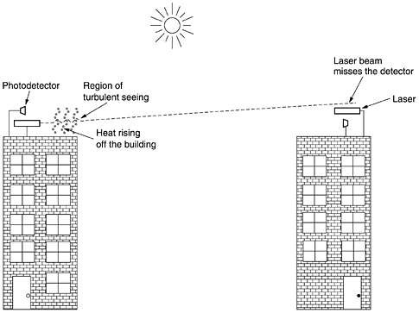It offers very high bandwidth and very low cost. It is also relatively easy to install.

A disadvantage is that laser beams cannot penetrate rain or thick fog, but they normally work well on sunny days.

### COMMUNICATION SATELLITES

**Communication satellite can be thought of as a big microwave repeater in the sky. It contains several transponders, each of which listens to some portion of the spectrum, amplifies the incoming signal, and then rebroadcasts it at another frequency to avoid interference with the incoming signal. The downward beams can be broad, covering a substantial fraction of the earth's surface, or narrow, covering an area only hundreds of kilometers in diameter. This mode of operation is known as a bent pipe.**

* 1. **Geostationary Satellites**
  2. **Medium-Earth Orbit (MEO) Satellites**
  3. **Low-Earth Orbit (LEO) Satellites**

## GEOSTATIONARY SATELLITES

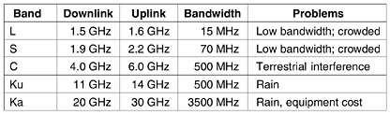The high-flying satellites are often called GEO (Geostationary Earth Orbit) satellites. Each transponder can use multiple frequencies and polarizations to increase the available bandwidth.

The first geostationary satellites had a

single spatial beam that illuminated about 1/3 of the earth's surface, called its footprint.

## VSATs using a Hub

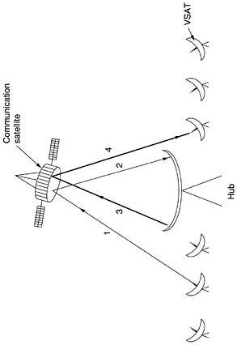

1. **MEDIUM-EARTH ORBIT (MEO) SATELLITES**

MEOs lower than the GEOs, have a smaller footprint on the ground and require less powerful transmitters to reach them. Currently they are not used for telecommunications. The 24 GPS (Global Positioning System) satellites orbiting at about 18,000 km are examples of MEO satellites.

## LOW-EARTH ORBIT (LEO) SATELLITES

The satellites are so close to the earth, the ground stations do not need much power, and the round-trip delay is only a few milliseconds.

* 1. **Iridium**
  2. **Globalstar**
  3. **Teledesic**

## IRIDIUM

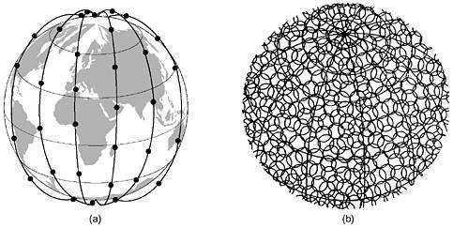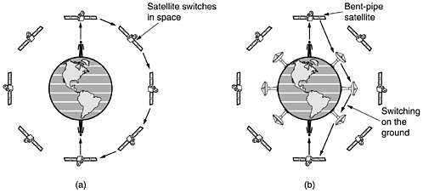

1. **The Iridium satellites form six necklaces around the earth.**
2. **1628 moving cells cover the earth.**
3. **Relaying in space.**
4. **Relaying on the ground**

## GLOBALSTAR

An alternative design to Iridium is Globalstar. It is based on 48 LEO satellites but uses a different switching scheme than that of Iridium. Whereas Iridium relays calls from satellite to satellite, which requires sophisticated switching equipment in the satellites, Globalstar uses a traditional bent-pipe design.

Public Switched Telephone Network (PSTN) is an agglomeration of an interconnected network of telephone lines owned by both governments as well as commercial organizations.

## Properties of PSTN

* It is also known as Plain Old Telephone Service (POTS)
* It has evolved from the invention of telephone by Alexander Graham Bell.
* The individual networks can be owned by national government, regional government or private telephone operators.
* Its main objective is to transmit human voice in a recognizable form.
* It is an aggregation of circuit-switched networks of the world.
* Originally, it was an entirely analog network laid with copper cables and switches.
* Presently, most part of PSTN networks is digitized and comprises of a wide variety communicating devices.
* The present PSTNs comprises of copper telephone lines, fibre optic cables, communication satellites, microwave transmission links and undersea telephone lines. It is also linked to the cellular networks.
* The interconnection between the different parts of the telephone system is done by switching centres. This allows multiple telephone and cellular networks to communicate with each other.
* Present telephone systems are tightly coupled with WANs (wide area networks) and are used for both data and voice communications.

## 

## C:\Users\Nagaraj\Desktop\2PSTN.png